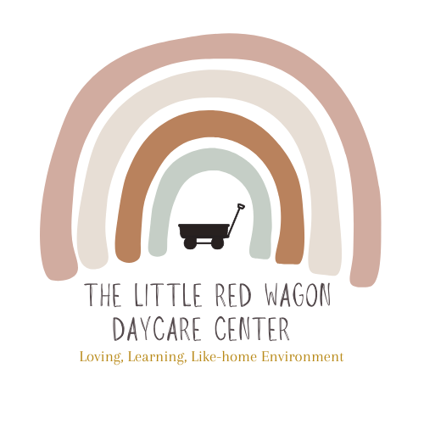

Parent Handbook

1510 W High Street Mt. Pleasant, MI 48858
Main:989-317-0777
Cell:989-506-0114
Connie-1122@hotmail.com

“Children are a gift from the Lord; they are a reward from him!”- Psalm 127:3

INTRODUCTION Welcome to THE LITTLE RED WAGON DAYCARE! Our daycare is unique for several reasons: group size, curriculum, and environment. We are a play-based daycare center and support a child-lead curriculum. We want children to be real and comfortable, have fun, in a loving home-like environment while still engaging in educational opportunities, essential for their development. For younger age groups we strive for consistent routines and structured activities to help them reach developmental milestones. For older children we strive for social/emotional and academic kindergarten readiness. We truly aim to connect and build strong relationships with each child and their families,

To facilitate greater understanding between parent(s) and provider, we have created this handbook covering childcare philosophies, business policies and expectations. Please read this carefully, and feel free to discuss with the Director any questions that you may have.

ADMITTANCE POLICY Parents wishing to enroll their child(ren) to The Little Red Wagon Daycare must first schedule a tour of our facility and interview with Director, Connie Marshall. Our center is small and close-knit, it is imperative that any new family accepted to our program understands and believes in our unique philosophy and environment. Communication is of the most importance, not only for the betterment of your child’s care and education, but for the daycare environment as well. Educators/providers are on the same team as parents, and if the dynamics of the two groups do not flow effectively, your child will not develop to his/her potential. An interview allows both parties to decide if our school is the best fit for each family individually.

WAITING LIST The Little Red Wagon Daycare is a desired environment and has a solid reputation in our community. As such, admittance to our program is in high demand. If a room is at capacity, you may place your child on our waiting list, and as soon as an opening becomes available, you will be contacted. Siblings of current students will be given priority. To be placed on the list, please contact the director. When enrollment is offered to an applicant, we require a decision within 48 hours. If enrollment is not accepted, the applicant will be removed from the waiting list.

CHILDCARE PHILOSOSPHY The Little Red Wagon Daycare’s mission is to provide a loving, like-home, quality educational childcare and preschool environment for children ages birth to 6 years. We intend to fulfill this mission by giving extra effort to the fundamentals of academics through increased focus of social and emotional skills which lay the foundation for all future learning. While creating strong and secure attachments with children, we help teach them to develop a healthy and balanced sense of self, as well as develop problem solving and communication skills. When using these techniques combined with a play-based learning approach we are providing a nurturing, safe, unique, and creative environment for children to grow and explore. We strongly believe in the power of learning through PLAY! By having open communication between parents and caregiver, we will create a more cooperative and hands-on approach to education.

COMMUNICATION Good communication between parent and provider is essential to any childcare program. When a new family joins our program, it is imperative we communicate openly about any concerns or questions that may arise, as well as share a similar childcare philosophy. We welcome questions, feedback, or discussions of any kind that are oriented towards a positive outcome for your child(ren). Sensitive issues will be discussed in private, and never in front of the children.
To further facilitate communication between parent and provider, The Little Red Wagon Daycare uses a parent communication app that allows teachers and staff to track children’s daily activities such as feedings, diaper changes and activities. These can be logged in real time and parents can see them on their phones or devices they have the app downloaded on. Sometimes there may be a bit of a lag when staff get busy, and they will catch up on logging at rest time or when there is a calmer moment in the day. This platform will also allow us to share some of the activities and happenings within our classroom, the current curriculum topics, upcoming events, closures, or any other pertinent, fun information that may be of interest to our families. Parents are asked to not seek out staff’s personal phone numbers (other than the director) as this app allows for messaging and direct communication to your child’s classroom teachers and staff as well.

ENROLLMENT POLICY To ensure commitment to a childcare position, there is a non-refundable application fee of $25 for new enrollments. There are also several forms that must completed and, in possession, before we can assume the responsibility of caring for your child. This is required by the state and if children’s files are incomplete, it can cause us to be out of licensing compliance. All forms must be updated every year, sometimes sooner, according to need. The forms are as follows:
- Signed parent handbook receipt and Rate Agreement
- Child Information Record
- Child Medication Form (if applicable)
- Child’s Health appraisal (will need to be filled out by a physician)
- Immunization Record
- Enrollment Form
- Signed Master Permission Slip
- Deposit (one week pay, applied to exit week)
You are required to keep the center informed of any change in addresses, telephone numbers, and other pertinent information listed on any/all of the above forms. If you have any questions regarding the completion of these forms, please feel free to ask.

LICENSING NOTEBOOK The Little Red Wagon Daycare keeps a copy of our center’s licensing notebook at the check in center on the front desk. It is in a black 3-ring binder and contains the following information:

(i) The licensing notebook contains all the licensing inspection and special
investigation reports and related corrective action plans for the last 5 years.
(ii) The licensing notebook is available to parents during regular business hours.
(iii) Licensing inspection reports, special investigation reports, and corrective
action plans from at least the past 3 years are available on the department’s childcare
licensing website at www.michigan.gov/michildcare.

The website where parents can access these rules is
www.michigan.gov/michildcare.

TRIAL PERIOD The first two weeks (14 calendar days) of the child's enrollment will be considered a trial period. During that time the parent or provider may terminate the childcare agreement at any time. After the trial period is complete, two weeks written notice is required to terminate the agreement. If a parent chooses to terminate without a two week notice, two weeks worth of pay will be billed to the family for services.

TUITION/PAYMENT PROCEDURES Your specific rates will be outlined in your Contract and Rate Agreement. Tuition is payable and due no later than drop off time on the first Friday of contracted weekly care (end of the week). There is no deduction for days child(ren) are sick, on vacations or days just taken off. The weekly rate is a flat fee and is due each week. Payment may be in the form of online payment via Quickbooks invoice system, cash, or check (please make check payable to: The Little Red Wagon Daycare), as long as no checks are returned for non-payment. There will be a late fee of $25 for each day that payments are not received. Repeated late payments may be grounds for termination. If there is non payment for two consecutive weeks, the center reserves the right to terminate childcare services.

AUTOMATIC PAYMENT Automatic billing may be set up for weekly payment, to set this payment feature up please use Quickbooks.

REGISTRATION FEE/LATE FEES There is a non-refundable $25 registration fee. There is also deposit of one week’s tuition required when your child registers, which will be applied to your child’s last week of enrollment. This deposit will be forfeited if care is terminated with less than two weeks’ notice.

This contract may be terminated at any time, for any reason by either party with proper notice. Proper notice will consist of written or verbal notice to the director not less than two weeks prior to the child’s last day of care. If you choose to terminate care with less than proper notice, you agree to forfeit the entire deposit.
If at any time, after consultation with the parent or guardian, center director feels that parent or child pose a safety risk to themselves or any of the children in care, a written notice terminating care immediately will be given. This action will be reserved for extreme instances only, and all attempts to resolve issues before resorting to termination of care would be taken. Under these conditions, forfeiture of the deposit would be determined by director.
A late fee equal to $10/per child/per each 15-minute interval that pick-ups are late, from the contracted hours, will be charged. Example: 1 - 15 minutes late= $10 per child fee; 16 - 30 minutes late= $20 per child. Late fees will be added to your account and must be paid with the following week’s tuition. This will be strictly enforced, and habitual lateness may result in termination of services.

NSF CHECKS If a check is returned for non-sufficient funds, you will be required to pay all fees that are incurred as a result of the returned check and subject to a $25.00 service charge. Childcare services will be immediately halted until full payment of tuition and NSF charges has been made, in CASH. In addition, only cash or credit card payment will be accepted from that point forward.

HOURS OF OPERATION Normal hours of operation are Monday through Friday from 7:30am – 5:30pm in Mount Pleasant and 7:00am-5:30pm in Remus.

CHILD’S HOURS Your child/children day begins as early as 7/7:30am and ends at no later than 5:30p.m. This means your child cannot arrive any earlier than 7/7:30am, please have your child here by 9:30am to maintain consistent schedule and routine for the program and your child. Children need to be picked up and out the door no later than 5:30pm. If the child is picked up after 5:30pm there will be a $10 late fee added to the amount due for the week. The provider needs to be informed of the child's set weekly schedule (arrival and pick up times) if the times need to change, please inform the director or lead teacher, as we try to keep a structured schedule. (we do not offer drop-in service). It is asked that parents please do not pick up or drop off their child between the hours of 1:00-3:00pm, as it is quiet/nap time.

8.Personal Belongings and Clothing:

Please have your child/children dressed and ready for play upon arrival. Please do not send your child/children barefoot. Even on hot days, shoes are needed for health and safety reasons. In the wintertime, please bring weather appropriate outdoor clothing for your child as it is needed for required outdoor time. This includes snow pants, coats, hats, gloves/mittens, and boots.

Please don't allow your child to come to daycare with a sippy cup (drink), food (other than packed lunch), or any toys that you wouldn't want shared with the rest of the children. ONE stuffed animal or security item for nap is fine but will be kept in a child’s bag or basket until then. Please DO NOT bring toys from home for children to play with. The Little Red Wagon Daycare is not responsible or liable for lost items. There are plenty of toys and items at daycare for children to use and engage with. Bringing items from home creates jealousy and unwanted problems. Mealtimes are set in our schedule and if a child is thirsty between mealtimes, water will always be available.

*Parents will only be asked to provide the following: Diapers and wipes, spare change of clothes, pacifiers, security items (if needed), blankets for rest, labelled bottles with formula and breastmilk for infants, packed lunch, and special diet foods.

ARRIVALS and DEPARTURES It is normal for some children to have difficulty separating from parents, or cry when dropping off. Please make your drop off brief as the longer you prolong the departure, the harder it gets. A smile, cheerful good-bye kiss, and a reassuring word that you will be back is all that is needed. In our experience, children are nearly always quick to get involved in play or activities as soon as parents are gone.

Our normal procedure is to release the child only to his/her parents, or someone else the parents designate. If someone other than the parent is to pick up the child, please notify us ahead of time. A verbal notice is fine on that day, if this person is on the list of people who are authorized to pick up your child. Please inform emergency contacts, or people designated to pick up your child, that they will need to provide ID the first time picking up the child. We do not mean to offend but we take the safety of our children extremely seriously.

ABSENCES There will be no refunds or adjustments made for days missed due to illness, holidays, or days off. A place has been reserved for each child that cannot be filled on a short-term basis, so it is necessary for you to pay for all days scheduled regardless of your child’s attendance. See holiday, illness policy, and closure sections of this handbook for more details.

CLOSED HOLIDAYS The following is a list of the paid holidays that The Little Red Wagon Daycare will be closed for each year. The center may close in observance of the holiday the day before or after if holiday is on a weekend:
- New Year’s Eve & New Year's Day
- Memorial Day & Friday Before
- Good Friday
- 4th of July (may have additional days for cleaning)
- Labor Day
- Thanksgiving Day & the day after
- Christmas Eve
- Christmas Day and the day after
- Week between Christmas and New Years
SPRING BREAK: The center may also close at the time of the public school’s Spring Break, if this were to be scheduled, parents would have at least a month’s notice to plan accordingly, and this week would NOT be paid for.
TEACHER IN-SERVICE & PROFESSIONAL DEVELOPMENT CLOSURES
To provide the highest quality care and education for the children in our program, The Little Red Wagon Daycare will close two (2) days each year for teacher in-service and professional development.
These dedicated training days allow our staff to complete required annual licensing and professional development hours, participate in CPR/First Aid updates, review health and safety procedures, strengthen curriculum planning, and enhance their knowledge of child development and best practices. Investing in our teachers ensures we continue to provide a safe, nurturing, and high-quality learning environment for every child.
An annual center calendar will be provided to all families each year and will include all scheduled closures, including professional development days, holidays, and other planned center closings. We encourage families to make alternate childcare arrangements for these dates in advance.

TUITION & PAYMENT INFORMATION
- These closures are considered scheduled paid closure days.
- Tuition remains due as normal for enrolled families, as care spots are reserved regardless of attendance or center closures.
- Eligible full-time staff will receive regular pay for these scheduled Professional Development Days.
We appreciate your understanding and support as we invest in ongoing education, training, and growth to better serve the children and families in our care.

CLOTHING/ATTIRE Children should arrive dressed for play and ready for the day! We like to have fun! Having fun involves outdoor play and lots of messy activities, so make sure that your child is dressed appropriately. Please do not dress your child in nice clothing and expect them to be spotless when you arrive to pick them up. Clothing should be comfortable and seasonally appropriate for outdoor play. Make sure to include hats, mittens, boots, and coats for cold weather. You will be expected to provide an extra change of clothing for your child. Accidents will happen, and it is always helpful that when they do, there is clothing that we can change your child into.

PARENTS SUPPLY: Diapers and wipes (you may bring a whole package of diapers/wipes to be stored at the center and will be notified through Parent communication app when supply is low), spare change of clothes (including socks and underwear in a labeled gallon ziplock), pacifiers, security items for rest/nap, blanket for rest time (center will be responsible for washing), and packed lunch. Good clothing is not recommended. Soiled clothing will be sent home and a clean change of clothes should be brought back the next day. If there is a special occasion that calls for special clothing (visit, party right after childcare, or photo shoot session), please send the special clothing with your child and we will help them clean up and get dressed prior to your arrival. All personal items must be clearly marked with the child's name. Items may be kept in child’s cubby or sent daily in backpack/diaper bag. If it becomes necessary for center to purchase supplies (such as diapers and wipes) and/or requested items for your child(ren) and not receive them, you will be billed on your next payment due date.

Infants: Formula and/or breastmilk needs to be in bottles sent daily. After use, the bottles will be rinsed and sent home with child for proper washing each day. The bottles need to be labeled with child’s full name and date the formula was prepared or milk was expressed. Parents will also provide sleep sacks for infants napping. The use of blankets is prohibited by licensing for children under 1 year of age. The center will be responsible for washing the sleep sacks and notifying parents when a child has outgrown a sleep sack. The center may provide a sleep sack if a family is unable to provide one.

DAILY SCHEDULE & CUT-OFF TIME: Young children enjoy a structured schedule that allows for flexibility. A schedule helps the day to flow more smoothly, allows the children to anticipate coming events, and aids in achieving a variety of learning goals. We will adhere to our written schedule to the best of our ability, keeping in mind, we are a play-based center and aim to follow the children’s interests as well as acknowledge that weather can play a factor in the schedule too. Please see the daily schedule included in handbook or ask your child’s teacher for the most current version. There will be times when adjustments must be made. We appreciate families considering our schedule when picking up or dropping off their children. We have a 10:00am drop-off cut off policy, meaning children must be at daycare/school by then. This ensures all children are on consistent routines and there are minimum disruptions. It is better if arrivals and departures do not occur during quiet/nap time, but if necessary (due to doctor appointment or emergency), please check with the director, and please take note of the fact that children may be sleeping and be considerate of this. Come and go as quietly and quickly as possible. Children who arrive during quiet time will be expected to rest or play quietly until the rest period is over.

MEALS parents will be providing lunches. The center will provide a healthy and nutritious breakfast, morning snack and afternoon snack, as well as make water available at all times. The menu is posted monthly on the front desk and meets CACFP nutritional standards. Mealtimes are as follows:

Breakfast: 7:30-8:30am

AM Snack: 10:00am

Lunch: 12:00pm

PM Snack: 4:00pm

Children who arrive after mealtimes (see Daily Schedule) should be fed before they arrive. Menus (see Sample Menus) will be posted on the bulletin board just inside the door. Copies of the menu are provided to parents through Parent communication app.

CLEANLINESS/HYGIENE We do our best to maintain strict cleanliness and hygiene standards. Children's hands are washed before and after meals and after toileting. We use paper towels for drying hands, so children do not have to use the same towel. Staff washes their hands frequently and uses antibacterial gel. Washable cots are used for naptime. Each child has a separate nap cot with blankets and pillows that are washed weekly (unless soiled, then they are washed as often as necessary) and cots are wiped with disinfectant.

All hard surfaces, bathrooms, and heavily touched areas are disinfected with a child safe cleaner that kills viruses and bacteria.

A 3-step method of wash, rinse, sanitize is used on a non-absorbent changing pad after diapering.
Children use separate cups, plates, bowls and eating utensils. Labeled water bottles are provided, and washed frequently, for your child to drink from throughout the day, whenever they choose. Children will also be provided the use of a cubby, for their personal belongings to be kept. This maintains healthy sanitary conditions, while also providing the benefit of personal space and a sense of belonging for each child.
TOILET TRAINING Toilet training will be done in a relaxed manner with the cooperation of the family. Thirty months of age is a good rule of thumb to start checking for signs of readiness. Toilet training cannot begin until the child is old enough to have independent urges. The child must also be ready in three areas. First, the child must be physically ready (meaning he or she can “hold on” for a period of at least an hour or more, although several hours is a better indicator of readiness, language is also needed so the child can communicate toilet needs). Second, the child must be intellectually ready (that is, he or she understands when and how to use a toilet). And third, the child must be emotionally ready (in other words, he or she must be willing to use the toilet). When the three areas of readiness occur together, toilet learning is usually easy and rather quick. When the time is right for your child, and until he/she is totally successful in his/her toileting, he/she should wear clothes that promote their independence. In addition, your child must have two complete changes of clothes (don't forget the socks!) The best items are shorts and pants with elastic waists, or dresses. Try to avoid really tight clothing, pants with snaps and zippers and belts, overalls, and onesies. These are difficult for children to remove "in a hurry". Do not bring your child in panties or underwear until he/she has naptime and bedtime control established.
We ask that you begin toilet training at home during a weekend or vacation after which, we will follow through and encourage your child here. When a child is ready, the process should go rather quickly. The child must be kept in pull-ups or training pants during the potty-training process. Putting a child in diapers part time, and training pants part time, can be confusing and delay the training process. Please keep in mind that the activity level here can distract your child from responding to an urge to use the potty, more so than at your home. Therefore, we will continue to use pull-ups until your child can and will announce that he/she must use the bathroom (not just at home, but here, as well) and can control his/her bladder and bowels for a few minutes beyond that announcement. Your child's readiness is something we can discuss because consistency between home and daycare will be very important. This is a special time for your child, a sign that he/she is growing up. Toilet training should be a positive experience.

NAPS/QUIET TIME There will be a designated nap/rest time each day (see Daily Schedule). All children must either nap or rest quietly during this period. Rest time gives everyone a much-needed break during the day. Studies have shown that kids who regularly get an adequate amount of sleep have improved attention, behavior, learning, memory, and overall mental and physical health. Without rest time, some children are argumentative in the afternoon, short-tempered with others, and not very happy when they go home in the evening.

PLAY-BASED CURRICULUM Our preschoolers love school. It's our number one priority. But what exactly is play-based learning? Play-based learning is a type of early childhood education based on child-led and open-ended play. If you’re picturing children finger painting or ‘playing house’, you’re spot on. Play itself is a voluntary, enjoyable activity with no purpose or end goal. Believe it or not, activities like this lay the foundation for a child to become a curious and excited learner later in life. Play-based learning helps children develop social skills, motivation to learn, and even language and math skills. Taking initiative, focused attention, and curiosity about the world are all a part of play. Children are naturally wired to do the very thing that will help them learn and grow. “The impulse to play comes from a natural desire to understand the world.” We know that in most cases, we are your child’s first experience away from home. At The Little Red Wagon Daycare, we make learning fun. Strategically planned curriculum creates easy avenues for your child to learn without a negative association. We set the foundation for positive school experience that they will take with them through the rest of their education.
We believe every child has a right to learn at his/her own pace, and should not be categorized solely by their age. In our unique class setting, we can teach and challenge your child according to his/her abilities. If by two and a half, she knows her letters, then by three and a half, she can probably grasp most of the phonetic sounds as well. If by three-and-three-quarters, your child can count and recognize numbers from 1-20, he/she should also be able to start doing simple addition and subtraction. Age does not dictate your child’s capabilities.

Children are able to learn and acquire so many skills through strategically planned curriculum and repetition. We make learning fun and you’ll be surprised what your child can accomplish and enjoy doing. We are all born innately with a desire to explore and learn, and it is only when we have failures, struggles and boredom within a classroom that we begin to dislike education. Our students look forward to our programs and will miss school on days off. Please note: the following is a list of skills we aim for our children to acquire before exiting the end of our program, but are not requirements for kindergarten.

- Recognizes, states, and writes all 26 letters of the
alphabet.
- Recognizes, states, spells and properly writes his/her first & last name.
- Recognizes, counts and writes numbers from 1-10.
- Can do simple addition and subtraction.
- Can recite the days of the week & months of the year.
- Can rhyme at least 2 words
- Knows colors and shapes
- Is aware of 5 senses
- Is independently able to dress himself/herself (with the exception of tying shoes).
- Is potty trained.
- Is socially able to interact in a group setting.
- Feels confident when speaking in front of a small group.
- Able to jump, hop, skip, climb, & walk backwards.
- Can cut, glue, and color independently.
- Able to follow 3 sentence instructions.
- Is able to sit quietly during story/group time.
- Knows how to stand in a line.
- Knows a large assortment of animal sounds.
- Can categorize where an object belongs.
Every day you will receive daily updates through the Parent communication app; a basic synopsis of your child’s day. We encourage you to discuss with your child what things he or she learned during the day. This not only opens communication between you and your child, but will also help your child recall activities, a valuable skill needed in formal schooling. Children learn through repetition and the additional enforcement they get from home, the more beneficial our program will be to them.

BIRTHDAY PARTIES Birthdays are a special time and we like to celebrate them! On your child’s special day, we will have a small celebration and recognize the milestone they have achieved. Feel free to send treats, such as cookies or snack cakes (mini cupcakes, not big ones please). Please let us know ahead of time what you are planning so that we do not duplicate sweets.

FIRE SAFETY We have a written fire evacuation plan and incorporate fire safety into our curriculum.
**Children and families are welcome in any areas of the building that are used for daycare purposes only. That being said, due to the pandemic we are implementing some safety precautions to maintain limited germ spreading and cross contamination. We of course want all families to feel welcomed in the environment where the child is daily, but we must also be safe.

INDOOR/OUTDOOR PLAY Indoor play: At the Little Red Wagon Daycare we believe in a play-based learning approach, and firmly believe children learn best through play! Our curriculum is child-lead and focuses on each child’s individual interests. We provide a variety of age-appropriate toys and materials for indoor play. Although the toys are categorized into learning centers, during free-play time we believe it is an important part of your child’s learning experience to explore outside the confinements of structured areas. Barbie’s may ride on trains, or Legos built into race tracks need cars to drive on it. Limiting imagination only stifles creativity, and we believe this to be a fundamental part of your child’s education. After play time, all toys will return to their designated areas. These activities help promote good health in our children. We try to instill a love for physical movement early on, so that they carry it with them into adulthood.
Outdoor play: We will play outdoors everyday that weather permits. We have a wonderful play area, equipped with climbers, sandbox, bikes, push cars, trucks, soccer nets, and a clubhouse. We also have sidewalk chalk, paintbrushes and other tactile toys making outdoor time an enjoyable event for your child. Other outdoor activities will include walks within the neighborhood, playground time at the park closest to the center, and water play (sprinkler and small pool during summer). When weather does not permit outdoor play, great lengths will be taken to do more music and movement and physical activities inside.
Please make sure that your child is appropriately dressed (see Clothing/Attire section) for outdoor play at all times.

CENTER RULES There are certain “house rules” that all children will be taught and expected to follow. This is for the safety and well being of everyone.
There will be no running permitted in the center, running is for outside time. Hitting, pushing, biting, grabbing, kicking, spitting, or pinching other children or adults will NOT be allowed. No standing or climbing on chairs or tables. There will be no use of obscene, derogatory, or disrespectful language.
Respectful treatment of other people and all property, toys, and furniture is expected. No smoking is permitted on the premises.

If a child consistently damages center property, parents may be presented with a bill for co

DISCIPLINE POLICY & CENTER RULES
At The Little Red Wagon, we are committed to creating a safe, nurturing, and structured environment where all children can learn, grow, and thrive. Our approach to discipline is rooted in guidance, teaching, and support—not punishment.
We believe behavior is communication, and our goal is to help children develop the skills needed for lifelong success.

Our Approach to Behavior Guidance
Our staff use developmentally appropriate strategies to support positive behavior, including:
- Redirection to appropriate choices and activities
- Positive reinforcement to encourage desired behaviors
- Body movement and sensory breaks to help regulate energy and emotions
- Social-emotional teaching (sharing, problem-solving, empathy, communication)
- Emotional regulation techniques (deep breathing, calming strategies, quiet spaces)
- Modeling respectful, calm, and appropriate behavior
Our teachers receive ongoing training in behavior management, classroom structure, and child development to best support all children.

Christian-Based Expectations
As a Christian-based program, we strive to model and teach:
- Kindness
- Respect
- Self-control
- Patience
- Compassion
We expect children to behave in a manner that reflects these values in age-appropriate ways.

Partnership with Families
We believe children are most successful when home and school work together.
- Staff are always open to partnering with families to support each child’s success
- Parents will be notified of ongoing concerns
- A parent consultation will be scheduled if behaviors become consistent or concerning
- We ask families to read nightly with their children to support one-on-one connection, language development, and vocabulary growth
We also have access to support from a Community Infant Mental Health Therapist for additional guidance and support when needed.
We ask families to support us by reinforcing:
- Respect for adults and peers
- Following directions
- Appropriate language and behavior
Additionally, families should understand that:
- We operate in a structured classroom environment
- Teachers must balance individual needs with group supervision, safety, and curriculum

Unacceptable Behaviors
The following behaviors are not permitted and will be addressed immediately:
- Physical aggression toward other children, staff, or self (hitting, kicking, biting, etc.)
- Destruction of property (intentional damage to toys, materials, or facility)
- Extreme disrespect, including:
  - Persistent backtalk
  - Defiance beyond age-appropriate behavior
  - Use of inappropriate or curse words
Note: Families will be responsible for replacing any intentionally damaged property.

Immediate Safety & Early Pick-Up Policy
If a child is:
- Posing a safety risk to themselves, other children, or staff
- Unable to regain control after multiple interventions
- Causing significant disruption that prevents staff from safely supervising the group
Parents will be contacted for immediate pick-up (within 1 hour of first phone call attempt).
This decision is made to protect:
- The safety of all children and staff
- The integrity of the classroom environment

Behavior Support & Intervention Process
We are committed to working through challenges with families. The following steps outline our process:

Step 1: Classroom Intervention
- Redirection, guidance, and behavior strategies implemented
- Staff monitor and document concerns

Step 2: Parent Communication
- Concerns shared with parents through DailyConnect
- Collaboration begins for consistency between home and school

Step 3: Parent Consultation Meeting
- Formal meeting to discuss behaviors
- Development of a behavior support plan
- Goals and strategies clearly outlined
- All parties sign the behavior plan

Step 4: Ongoing Monitoring
- Progress tracked
- Adjustments made as needed
- Continued communication with family

Step 5: Escalation (If Needed)

If behaviors continue to be:
- Severe
- Highly disruptive to the classroom
- Or impacting the safety and supervision of others
We will:
- Require early pick-up, child must be picked-up with 1-hour from time of first phone call attempt.
- Recommend outside support or evaluation

Step 6: Alternative Placement / Expulsion Consideration
If all available strategies and supports have been exhausted and:
- The child requires more support than we are able to provide, or
- The classroom environment is consistently disrupted, or
- Safety concerns continue
We will work with the family to explore alternative accommodations or resources.
*While expulsion is never our goal, it is a possible outcome in extreme situations when a child’s needs exceed the level of care we are able to safely provide.

Our Commitment
We are committed to:
- Supporting each child with compassion and consistency
- Supporting families through open communication and partnership
- Supporting staff so they can maintain a safe, structured, and positive classroom
At the same time, we must ensure that:
- All children are safe
- Teachers can effectively supervise and teach
- The classroom remains a positive learning environment for everyone

Prohibited Discipline Practices & Licensing Compliance
Under NO CIRCUMSTANCES will there be any:
- Spanking or physical punishment
- Physical abuse of any kind
- Verbal abuse or name-calling
- Isolation used as punishment
Additionally:
- Food will never be withheld as a form of punishment
- Sleep or rest will never be withheld as a form of punishment
We understand that abusive treatment of children is strictly prohibited by law and by childcare licensing regulations. The Little Red Wagon fully complies with all state licensing requirements.

Parent Communication & Program Limitations
It is always our absolute last resort to contact a parent due to a child’s behavior. However, if needed, we will do so for additional support, especially in situations involving safety concerns or significant disruption.
Staff are intentional about communicating with families regarding their child’s day, behaviors, and progress.
In the extreme event that severe and consistent behaviors persist, the center reserves the right to terminate services at the Director’s discretion if we determine that:
- A child’s behavior poses a danger to other children or staff
- The behavior significantly disrupts the classroom environment
- The child requires a level of care beyond what the center can adequately provide compensation of replacing said property.

ILLNESS
Mary had a little cold, but wouldn’t stay at home,
And everywhere that Mary went, the cold was sure to roam
It wandered into Molly’s eyes & filled them full of tears-
It jumped from there to Bobby’s nose and thence to Michael’s ears-
It painted Anna’s throat bright red, & swelled poor Jennie’s head
Dora had a fever and cough put Jack to bed.
The moral of the little tale is very quickly said,
She could have saved a lot of pain with just one day in bed!
The Little Red Wagon Daycare is a "well-child” daycare facility. At no time do we provide sick childcare. The following illness policies will be strictly enforced, for the health, well-being and safety of all concerned.
Family-Convenient Sick Child Policy: At The Little Red Wagon Daycare we understand the important role we play in your family’s life. We know that you have your child enrolled in a quality daycare program because you need childcare services to work and support your family. We aim to provide a convenient illness policy that allows for flexibility and fairness concerning childhood illness, while still being, smart, cautious, and safe with the health of our staff and children. Given these unprecedented times we find ourselves in, it’s important to be considerate of the group and health of others. LARA, in accordance with the CDC has laid out covid guidelines for licensed providers to follow. These guidelines are recommendations and will be considered along with advice from the local health department concerning covid-19 closures and isolation practices. The Little Red Wagon’s best practice thus far throughout the pandemic has been to remain transparent and honest with families about exposures and positive cases.
We also understand other illnesses than covid can and do still occur in childcare settings. Please remember that this is daycare, and we live in a region where illness is strong during the winter months, some illness is inevitable. With many small children together, germs will spread, and illness will occur. Unfortunately, this is just a fact of any daycare or school setting. That being said, we do everything possible to keep illness from spreading and by following and enforcing this illness policy.
Under no circumstances may a parent bring a sick child to day care, if the child shows any signs of illness (see SYMPTOMS REQUIRING REMOVAL OF CHILD FROM CHILD CARE) or is unable to participate in the normal routine and regular day care program. Sick children expose other children, as well as staff, to the spread of their illness and require additional care and attention that we are unable to give. Moreover, sick children want care from their parents in the comfort of their own homes. If other children become ill due to exposure to your sick child, either because he/she was returned to day care before full recovery or because he/she was not picked up promptly upon notice of becoming ill, other parents will be unnecessarily inconvenienced and exposed. Because this is disruptive to other children and their families, as well as our own, your cooperation on this issue is extremely important.
Every effort is taken to reduce the spread of illness by encouraging hand washing and other sanitary practices (see Cleanliness and Hygiene).
If your child is unable to participate in the normal activities of the day care (including being able to play outside), then your child MUST stay home.
Children will be visually screened and checked for fever when they arrive in the morning. In the event a child becomes ill and needs to be picked up, the parent(s) will be called and expected to come pick the child up within one hour (60 minutes). If the parent(s) cannot be reached, or have not arrived within an hour, the emergency contact person will be called and asked to come and pick the child up.
A sick child will not be permitted to return to care for 24 hours after condition has returned to normal. The child may return 24 - 48 hours (depending upon the illness) after they have received the first dose of an antibiotic. If a child receives an antibiotic for an ear infection, (s)he may return to day care immediately if he has been free of other symptoms mentioned for at least 24 hours. If you aren't sure about whether or not to bring your child to care, please call to discuss it. A note from your doctor DOES NOT trump this daycare illness policy. Allergy related symptoms, and non-communicable illnesses do not require exclusion.
Symptoms requiring removal of child from daycare:
- Fever: Fever is defined as having a temperature of 100.4°F (a child needs to be fever free for a minimum of 24 hours before returning to daycare, that means the child is fever free without the aid of Tylenol®, or any other fever reducing medicine.)
- Fever AND sore throat, rash, vomiting, diarrhea, earache, irritability, or confusion.
- Diarrhea: runny, watery, bloody stools, or 2 or more loose stools within last 4 hours.
- Vomiting
- Frequent scratching of body or scalp, lice, rash, or any other spots that resemble childhood diseases, including ringworm, hand foot & mouth, and pink-eye.
- Frequent, harsh Cough
- Runny nose, that isn’t usual for child
- Heavy congestion/drainage
Substitute Care Due to the size of our facility, from time-to-time substitute care may be required. We will make every effort to find alternate care vs closing a room or the whole center. Subs must meet all state licensing requirements to work with children in a licensed center. Substitution is extremely rare.

MEDICATIONS Parents will provide any medications needed by the child, including over-the-counter and prescription medicine. Written authorization is needed for The Little Red Wagon Daycare staff to administer ANY medication, prescription or over-the-counter. All medicines must be in their original container with pharmacist or manufacturer's label, child's name, dosage instructions, current date, name of medication, and times to be administered clearly written.

DAYCARE CLOSURES The Little Red Wagon Daycare makes every effort to avoid closing.

Daycare will only close in extreme circumstances, such as the following:
- If a communicable disease caused for lack of adequate staffing to operate the facility in compliance with state licensing ratios.
- Power Outage
- Severe Weather causing CMU or Mid-Michigan College to delay or close.
- Lack of heat or air-conditioning source
- Lack of water source
- Armed/dangerous persons at large in neighborhood.

In the event of a daycare closure, regular payment is required. **In the event a longer shut down were to occur, such as a week or more as experienced with the Covid-19 pandemic, weekly rates would be discounted by 50% or more based on circumstance.

MEDICAL EMERGENCIES Minor bumps and scratches are inevitable, but we make every effort to keep the children safe through supervision and childproofing. Minor injuries receive appropriate first aid, and if an emergency injury or illness occurs, you will be contacted as soon as possible. If necessary, your child will be taken to the nearest hospital where you will be asked to meet us. If you are not going to be at your usual place of employment, or at home, please make sure that we have a number where you can be reached.
Parents are responsible for all costs involved in emergency medical treatment, including emergency transportation, if required. The owner of The Little Red Wagon Daycare will not be held liable for any sickness or injury of either parent/guardian or child while on these premises, or while the child is in the company of the provider during field trips or outings.
Suspected Child Abuse As a licensed center, we are required to report all suspicions of child abuse to our local police department or child protection agency.

EMERGENCY PROCEDURES In the event of an emergency concerning the safety of the children in our care, such as a fire, flood or evacuation of the center for any natural or unnatural reasons, we will take the children out of the affected area. Parents will be notified by telephone where the children will be taken.
Our primary point of contact will be the fenced in play area on the center’s property. If for some reason this is not far enough, we will then take the children to Recker’s Motor Sports parking lot.
A conscientious effort will be taken to secure the safety and well being of your child(ren) and you will be notified as soon as possible of any such emergency and the location in which we are at.
Lockdown drills are becoming more common as individuals continue to attack schools and school grounds. In the case of an intruder or other criminal emergency, each room has a specific plan to follow. All windows and doors will be locked and secured until law enforcement assures us that it is safe to come out. During lockdowns, parents can be contacted but will be unable to pick up or drop off children.

DISASTER PLAN OUTLINE
Each classroom has a specialized set of instructions for handling each if the following types of disasters:
Emergency Procedures including:
Fire, Tornado, Other Natural or Man-Made Disasters, Serious Accident, Illness and Injury
Crisis Management Plan including:
Intruders, Active Shooters, Bomb Threats, Other Man-Made Events
Procedures Include Plans for:
Evacuation, Relocation, Shelter-in-place, Lockdown, Contacting Parents, Reuniting Families
Accommodating Special Needs, Accommodating Chronic Medical Conditions and Accommodating Infant and Toddlers

PRESCHOOL DISASTER PLAN

Main phone number: (989) 317-0777 Cell: (989) 506-0114

Address: 1510 W. High St Mt. Pleasant, MI 48858
Primary Emergency Meeting Place:
Fenced-in playground area
Secondary Meeting Places:

Reckers Motor Sports or Billy’s parking lots

TELEVISION/VIDEO POLICY Television will only be allowed for Movie Day or for a brief period of time as an extension to a learning theme. We believe that you are bringing your child here for an education and social interaction. Television diminishes both elements. We are by no means saying that television should not or does not play a role in your child’s life. We just have limited time for it in our busy schedule.

TERMINATION POLICY We reserve the right to terminate for the following reasons (but not limited to):
- Failure to pay (2 weeks without on time payments warrant termination)
- Failure to complete the required forms
- Lack of parental cooperation
- Failure of child to adjust to the center after a reasonable amount of time
- Physical or verbal abuse of any person or property
- Our inability to meet the child's needs
- Lack of compliance with handbook regulations
- Serious illness of child or provider
- Part Time spot needed for a Full-Time spot
We appreciate as much advance notice as possible when terminating. Parents are required to give two weeks written notice when they decide to terminate childcare. The two weeks will be paid in full, regardless of whether the child is in attendance.
We will give two weeks written notice of termination for which full tuition is due, whether the child is in attendance. The provider reserves the right to give written notice of immediate termination where there are extreme circumstances that affect the well being of the provider or other children in attendance. In this situation, the two weeks payment of tuition is still required.

TAX INFORMATION The Little Red Wagon Daycare will supply families with a year-end summary of all daycare fees paid during the year for tax purposes. This will occur in January each year or when services are terminated.

RECALLS On a regular basis, https://www.michigan.gov/lara/0,4601,7-154-89334_106253_106291_106842---,00.html website will be checked for the list of product recalls that may be found within our center. Any toy, equipment or furnishing found to be on this list, will be removed from the center immediately.

REVISIONS TO THE HANDBOOK/CONTRACT
All families will sign a yearly revision to this handbook and the accompanying contract each year. We reserve the right to make changes in rates and policies, as we deem necessary. You will be notified, in writing, of any changes that may occur. Every attempt will be made to give at least two weeks’ notice of changes.

For licensing questions or concerns about this center:

Please call Isabella Child Care Licensing Consultant: Michael Skonieczny 989-289-8572

For rules regulating childcare centers, please visit: https://www.michigan.gov/documents/lara/BCAL_PUB_8_3_16_523999_7.pdf

Agreements
My signature below affirms that I have read and agree to all information in the Little Red wagon Daycare Parent Handbook.
I agree, by enrolling my child at The Little Red Wagon Daycare our family agrees to adhere to the policies in the handbook and agrees to follow any decision or policy implemented. Failure to comply with policies in the LRWD Handbook may result in dismissal from The Little Red Wagon Daycare program.
The Little Red Wagon Daycare admits children to programs on a space available basis, without regard to race, religion, creed, color, national origin, or sex.
I have received and read this acknowledgment of receipt, know, and understand its contents, and sign the same of my own free will.

Agreements
My signature below affirms that I have read and agree to all information in the Little Red wagon Daycare Parent Handbook.
I agree, by enrolling my child at The Little Red Wagon Daycare our family agrees to adhere to the policies in the handbook and agrees to follow any decision or policy implemented. Failure to comply with policies in the LRWD Handbook may result in dismissal from The Little Red Wagon Daycare program.
The Little Red Wagon Daycare admits children to programs on a space available basis, without regard to race, religion, creed, color, national origin, or sex.
I have received and read this acknowledgment of receipt, know, and understand its contents, and sign the same of my own free will.

Parent Signature___________________________________Date_________________

The Little Red Wagon Daycare Rate Agreement
The following is a chart of the current rates at the center. At The Little Red Wagon Daycare, we strive to keep rates affordable for families and understand paying for daycare can be a financial strain for families. We also aim to pay our staff a fair wage. I also always like to remind families that enduring childcare expenses isn’t a forever commitment. Children are only young and in need of daycare services for a short season in life. Please keep in mind that the owner/director is a mom too and understands the situations family’s face. Thank you for your business and welcome to our family!
Mount Pleasant Rates:
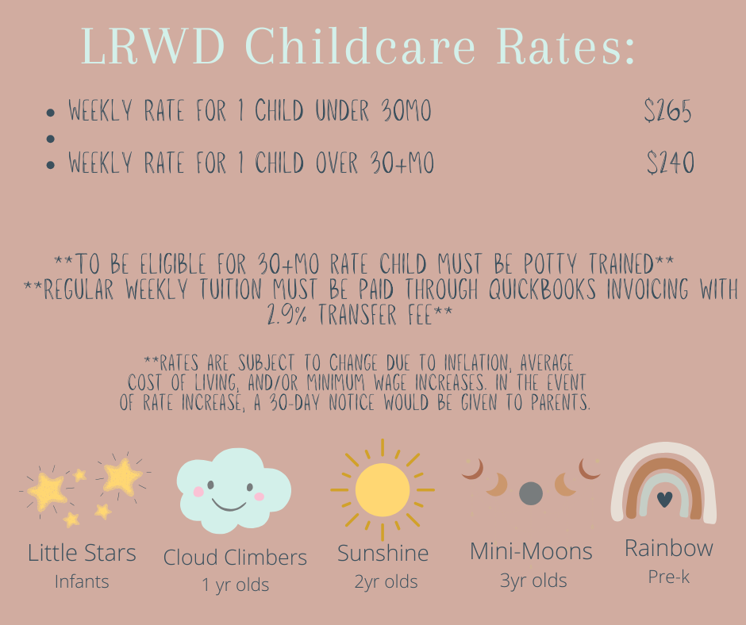

I agree to pay the following weekly rate: $_________________________________________________
Children’s name(s) and age(s): _______________________________________________________________
Parent’s Signature: _________________________________________________Date:______________

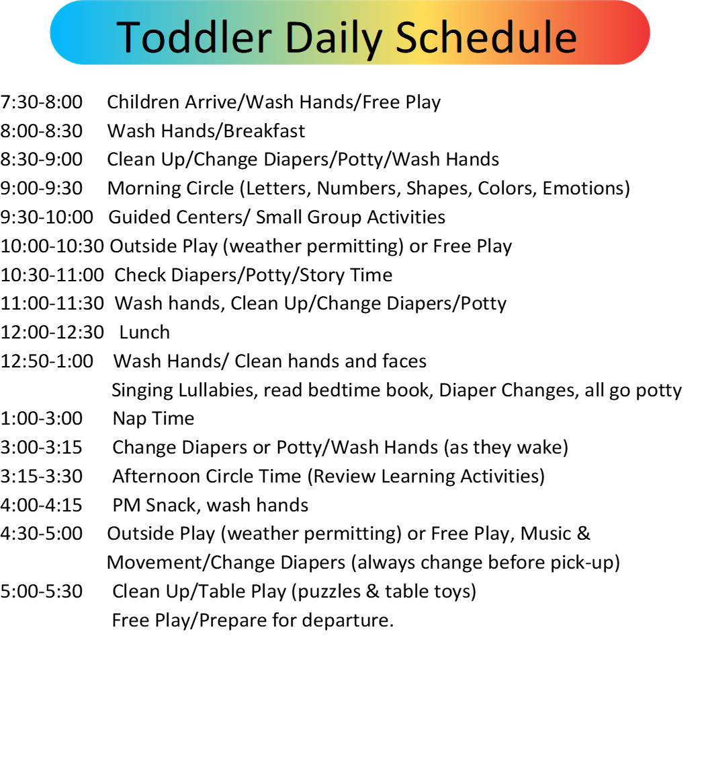

LRWD Field Trip Permission Form

Dear Little Red Wagon Daycare Parents/Guardians:
At our center we will be taking various field trips during regular daycare hours that go along with areas of focus in our classrooms/curriculum. Our licensing rules require your written permission for your child to attend field trips. Unless otherwise notified, your child will be transported by ICTC to and from the destination. On occasion, your child may walk to and from the destination if it is within walking distance of the center.
Rather than sending home a permission slip for each separate trip, this one form covers all field trips throughout the year. Prior to each trip, we will post on our parent communication app and/or email the parents of the children participating when, where and the method of transportation for each trip. If you prefer that your child not attend a particular field trip, please let your child’s teacher know prior to the day of the trip.
Please indicate below whether your child will be able to participate in all field trips. If you have questions, please contact Connie at 989-506-0114.
I hereby give my permission that my child attends all LRWD field trips. I understand that I will be notified prior to each individual field trip as outlined above. I will notify the classroom teacher if my child will not be going on a particular field trip.
Y________N________
Parent Signature:_____________________________________
Date:_______________

LRWD Media Release Form

Dear LRWD Parents/Guardians,
At The Little Red Wagon Daycare, we like to share what are children are doing with the community and other families within our daycare family. That being said, we also understand and respect privacy as well. We will only share photos of children who we have permission to do so. The Little Red Wagon Daycare will not photograph, videotape and/or voice tape individuals in its program without consent. This form allows you to give permission for your child/children to be photographed, videotaped and/or voice taped by daycare center staff.

I hereby give permission for the staff of the LRWD to photograph, videotape and/or voice tape my child.
Y_________N__________
Parent Signature:___________________________________________
Date:__________________

